### PAWSPORT: Unifying Pet Health Records for Seamless Care and Travel

### Introduction

PAWSPORT is a centralized digital platform designed to simplify pet health record management and facilitate seamless pet care and travel. Pet owners often struggle with fragmented records across different veterinary systems, leading to inefficiencies and stress, especially during travel. Our solution addresses these challenges for pet owners aged 25-40 who frequently travel with their pets.

Team Members and Roles:

* Gucen Zhang: Project Lead & User Testing Lead. Led usability test planning and execution, coordinated team efforts for user research
* Jiaqi Hu: Documentation & Research Lead. Managed test documentation, prepared comprehensive reports, conducted user interviews
* Shaokai Lin: Prototype Development Lead. Oversaw prototype iterations, implemented user-driven revisions, developed final designs
* Zeyu Shen: Analysis & Strategy Lead. Analyzed evaluation results, planned testing strategies, documented design decisions

### Background

Problem Definition:  
Pet owners face significant challenges managing their pets' health records, which are often dispersed across various veterinary clinics and platforms. This fragmentation complicates routine care, emergency situations, and travel preparation, leading to increased costs, delays in care, and missed vaccinations.

Motivation:  
The growing trend of pet ownership among millennials, coupled with their propensity to travel with pets, highlighted the need for a unified solution. We were inspired to address the inefficiencies in pet health management to enhance both pet welfare and owner convenience.

### User Research

User Definitions:

* Primary Users: Pet owners aged 25-40 who travel domestically or internationally with their pets at least twice a year.
* Secondary Users: Aspiring pet owners considering the logistics of pet ownership.
* Tertiary Users: Veterinarians, airline staff, and pet insurance providers involved in pet health or travel processes.

Research Methods:

* Interviews: Conducted with 2-3 pet owners to understand individual challenges.
* Surveys: Distributed online to collect quantitative data from a broader audience.
* Follow-Up Interviews: Engaged aspiring pet owners to explore potential barriers and needs.

Participant Recruitment:

* Survey Participants: Initially recruited 10 pet owners through acquaintances, then expanded through referrals.
* Interview Participants: Selected based on unique survey responses and experiences, representing different user backgrounds (design, technology, and fitness professionals).

Key Insights:

1. Fragmented Records: Managing health records across multiple systems is a significant pain point.
2. Travel Concerns: Preparing documentation for domestic and international travel is stressful and inconsistent.
3. Digital Preference: Users prefer centralized digital solutions, with 90% expressing interest in a unified app.

Tasks/Results :

1. Setting and Receiving Health Reminders (Existing Task, Easy)
2. Retrieving Vaccination History (Existing Task, Easy)
3. Streamlining Pet Care Appointments (New Task, Easy)
4. Emergency During Trip (New Task, Moderate)
5. Cat Traveling Sedation Medication Reminder (New Task, Easy)
6. Managing Pet Relocation Documentation (New Task, Hard)

### Prototypes and User Testing

#### Paper Prototype:

The initial prototypes were developed for two primary tasks:

1. Scheduling a Vaccine Appointment
2. Managing Travel Documents

Key features included document upload functionality, task navigation for pet-related travel and vaccination needs, and visual feedback for user actions. These prototypes were reviewed and tested iteratively through heuristic evaluations and usability tests.

#### User Testing:

User Recruitment:

* Selected three users representing different perspectives:
  + Architectural Designer: Tech-savvy but new to pet apps
  + Software Developer: Experienced with technology, focus on travel
  + Fitness Coach: New pet owner, testing first-time user experience

Testing Methods and Tasks:

* Test Protocol:
  + Welcome and Introduction (2-3 minutes)
  + Task Instructions (15-25 minutes)
  + Follow-up Tasks
  + Post-task Questions
  + Reflection and Ratings
  + Closing
* Key Testing Tasks:
  + Task 1: Scheduling/Updating Vaccination Records
  + Task 2: Managing Travel Documents
  + Task 3: Navigating Help Documentation
  + Task 4: Creating and Managing Trips
  + Task 5: Document Organization and Review
* Team Roles During Testing:
  + Primary Facilitator: Guide participants through tasks
  + Computer: Manipulate prototype based on interactions
  + Observers: Document responses, timing, and behaviors

Heuristic Evaluation:

* Issues were identified across usability heuristics such as user control and freedom, visibility of system status, and match between system and the real world.
* Key revisions included:
  + Adding "VIEW," "EDIT," and "DELETE" options for document management.
  + Enhancing navigation with "Back" and "Proceed" buttons.
  + Implementing visual highlights for selected pets and a pet selection interface.
  + Adding a document preview feature and clear upload statuses.

Usability Testing: Three rounds of usability testing were conducted with different participant profiles:

1. Test 1 (Architectural Designer):
   * Identified the need for a document overview section displaying expiration statuses.
   * Introduced visual progress indicators for document uploads.
   * Enhanced vet rating displays to include category-specific reviews.
2. Test 2 (Software Developer):
   * Suggested implementing a "My Trips" page for managing multiple trips.
   * Proposed sorting documents by categories like health or identification for better organization.
3. Test 3 (Fitness Coach):
   * Highlighted the importance of tutorial prompts for first-time users.
   * Recommended adding a community feature for users to share travel insights.

#### Revisions After Testing:

* Added comprehensive navigation aids (e.g., "Travel" page, consistent "Back" buttons).
* Improved clarity in document organization, including status indicators and grouped categories.
* Enhanced visibility and feedback across tasks, such as vaccination scheduling and document management.

#### Final Product Features:

1. Travel Management:
   1. Centralized "Travel" page with task-specific details.
   2. Document upload and management with expiration tracking and status indicators.
2. Vaccination Scheduling:
   1. Vet selection interface with category-specific ratings and reviews.
   2. Notifications for expiring vaccines and direct access to relevant tasks.
3. Community Building (future feature):
   1. Platform for users to share travel tips and location-specific insights.

Final Paper Prototype:

1. Scheduling a Vaccine Appointment



1. Managing Travel Documents:

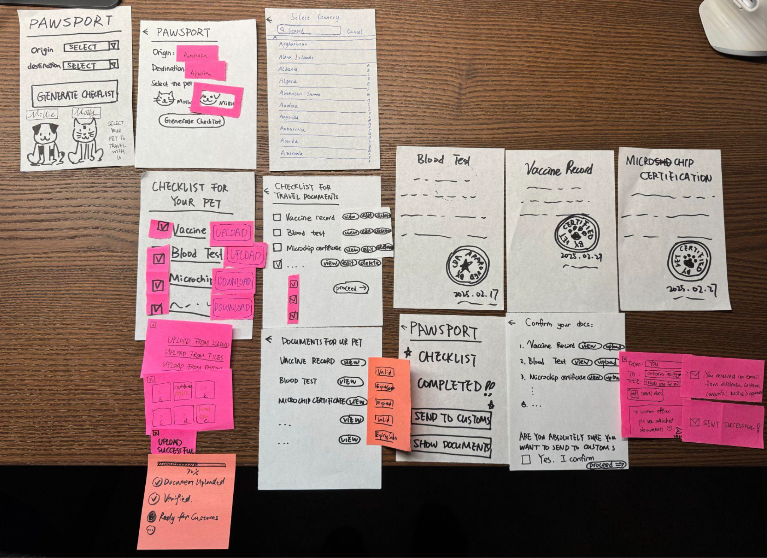

Hi-Fidelity Prototype:

1. Scheduling a Vaccine Appointment

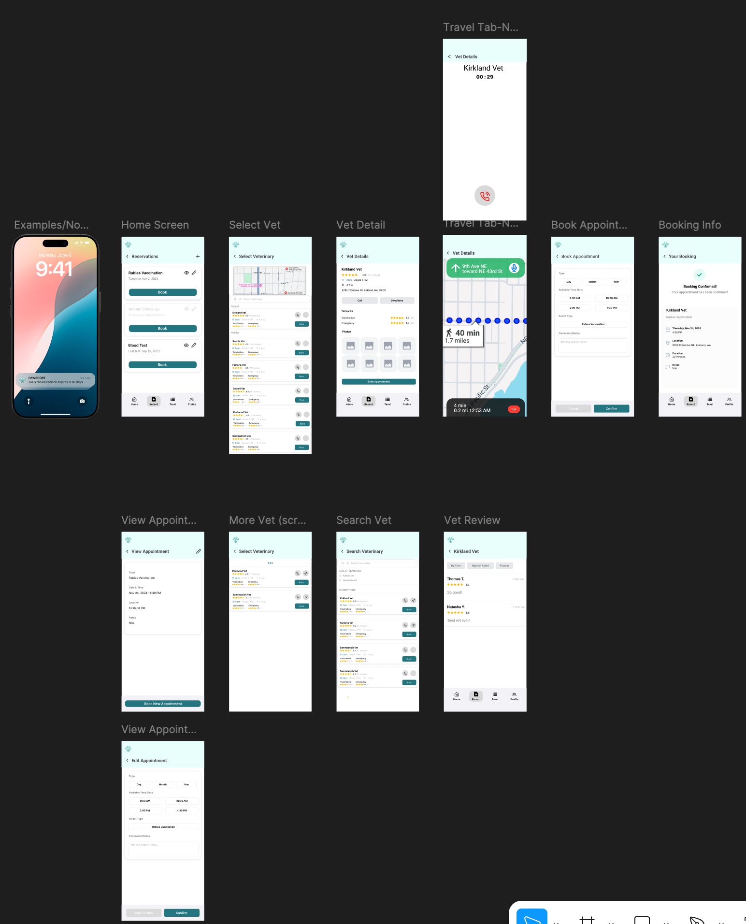

1. Managing Travel Documents:

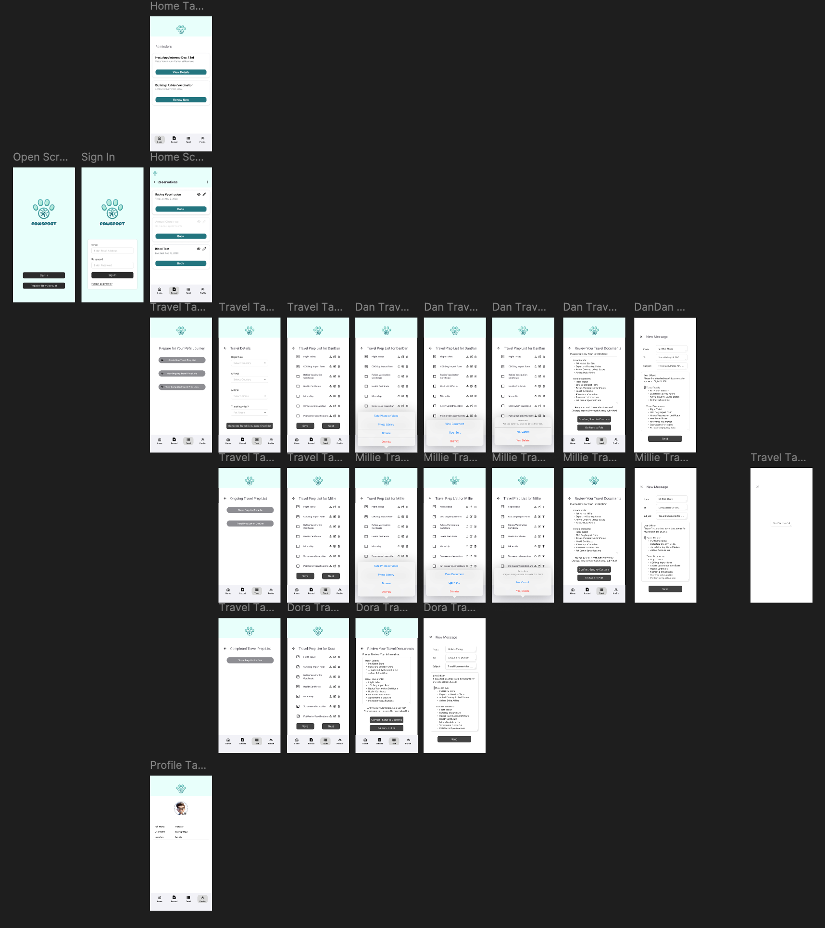

### Project Retrospect

Learnings:

* Pet owners prioritize ease of use and efficiency in managing health records.
* Streamlined travel preparation significantly reduces stress for users.

Limitations:

* Integration with veterinary systems is a challenge due to varying formats and standards.
* User adoption depends on trust and ease of onboarding.

Roadmap and Impact:

* Future Enhancements: Incorporating AI for document autofill, deeper integration with veterinary databases, and multilingual support.
* Potential Impact: PAWSPORT can improve pet care by ensuring timely access to health records, reducing travel-related stress, and promoting better health outcomes for pets.